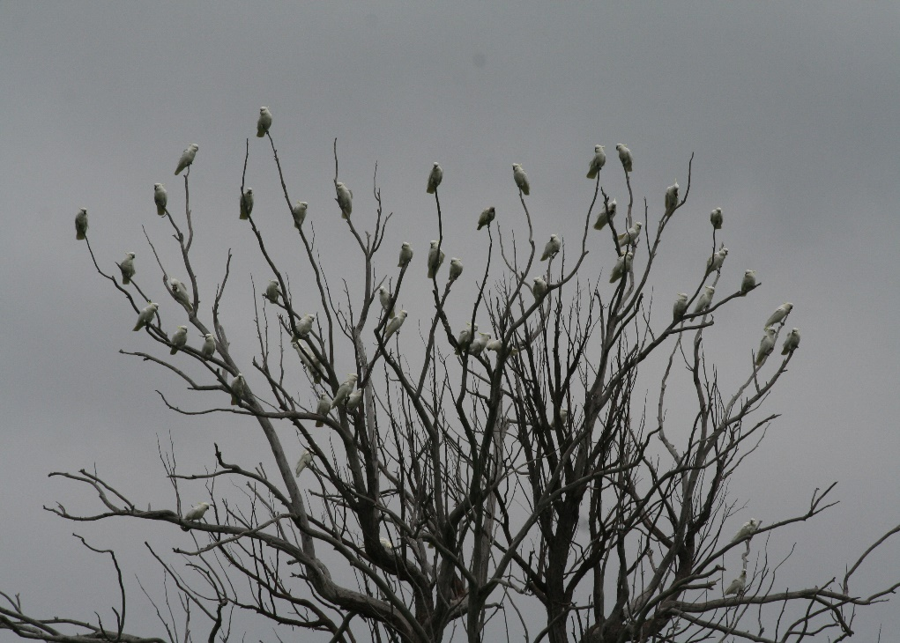

Bellbrook Press invites you to the book launch by
Elsa Atkin AM, former CEO National Trust of Australia.
‘CROSSING THE DIVIDE’ poetry by George Clark.
Thursday 8th September 2016, 5.30 - 8pm . RSVP 5th September 2016
Judith Wright Room, Garryowen House, NSW Writers Centre,
Callan Park, Balmain Rd. Rozelle.
sponsored by :-
BELLBROOK FRIENDS WINES

